LAUNCHPAD (Launchpad User Guide pg 37):
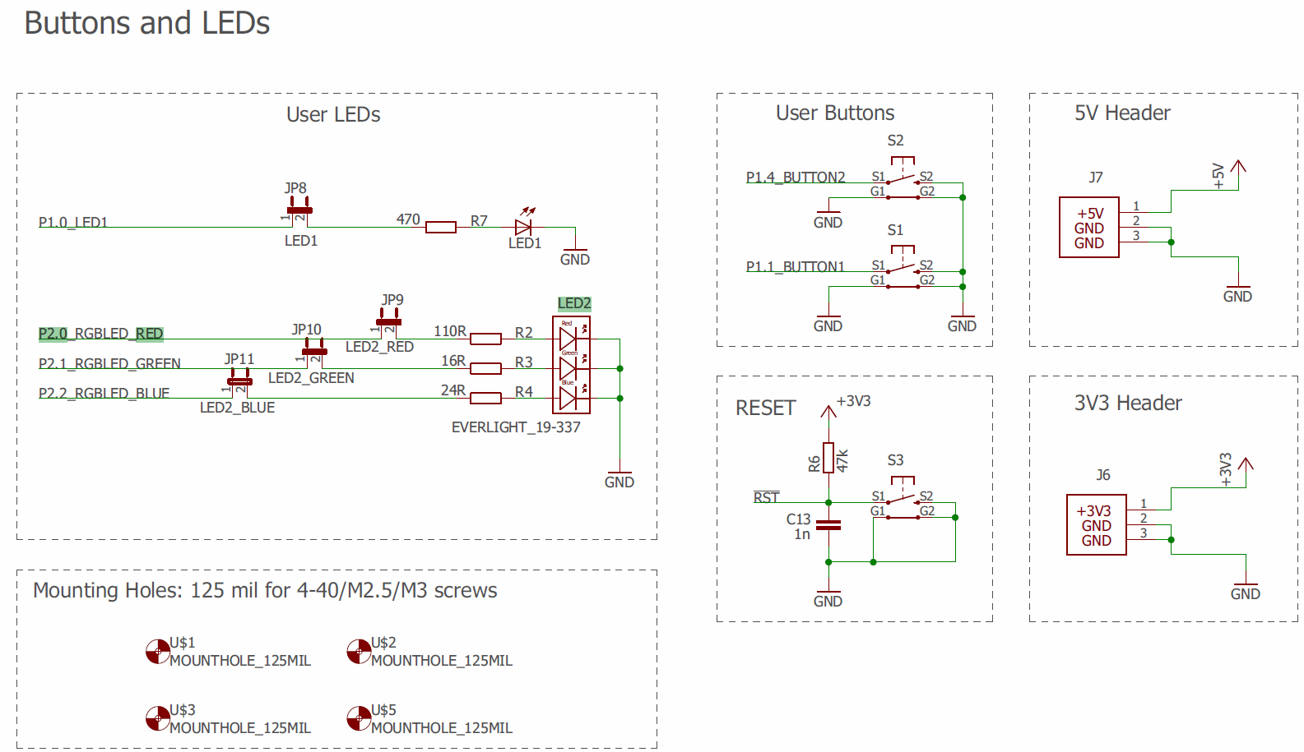
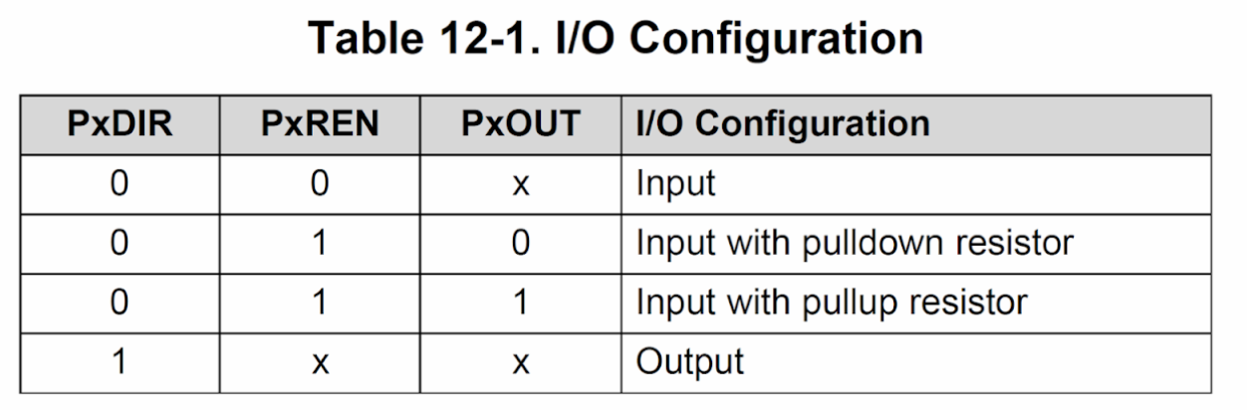
ALL MCU pin/register memory addresses (MCU Datasheet pg. 100):
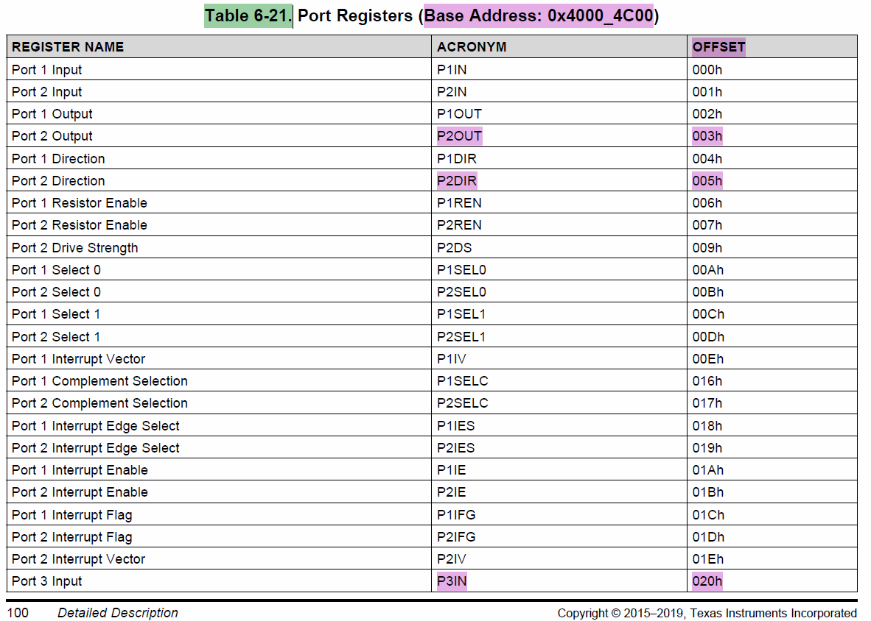
…
BoosterPack User Guide (BoosterPack User Guide pg. 5):


